## EXPERIMENT 7

## Aim: To analyse the circuit and truth table of 4-bit SIPO (serial input parallel output) shift register by using IC 7474 (D flip flop).

### PRE TEST

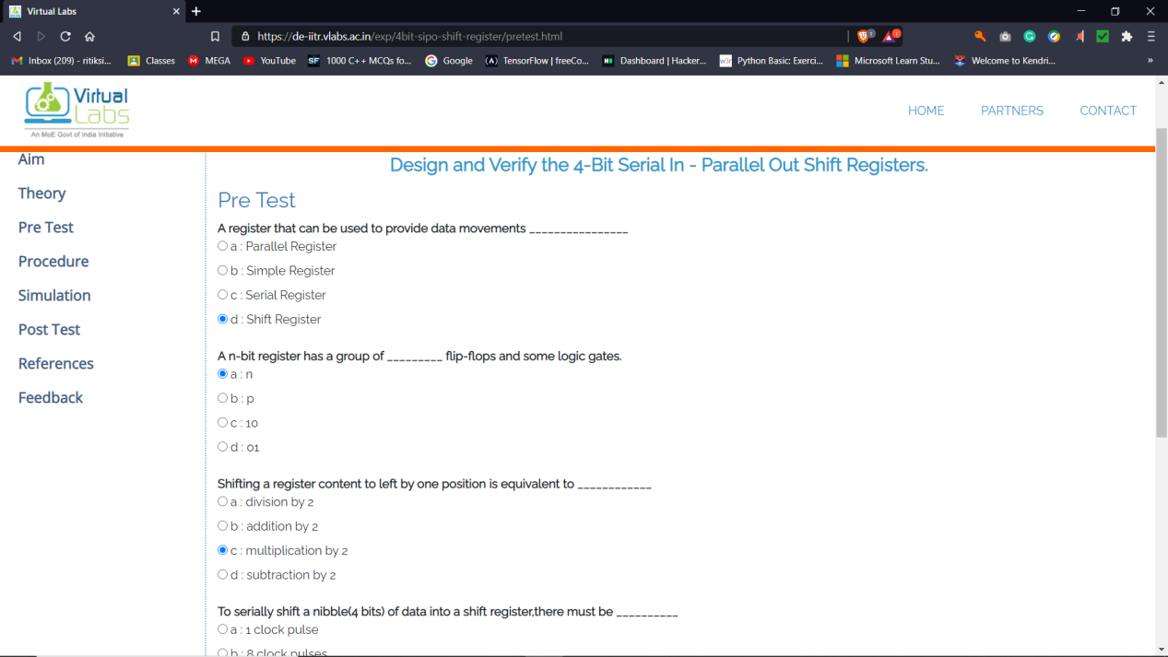

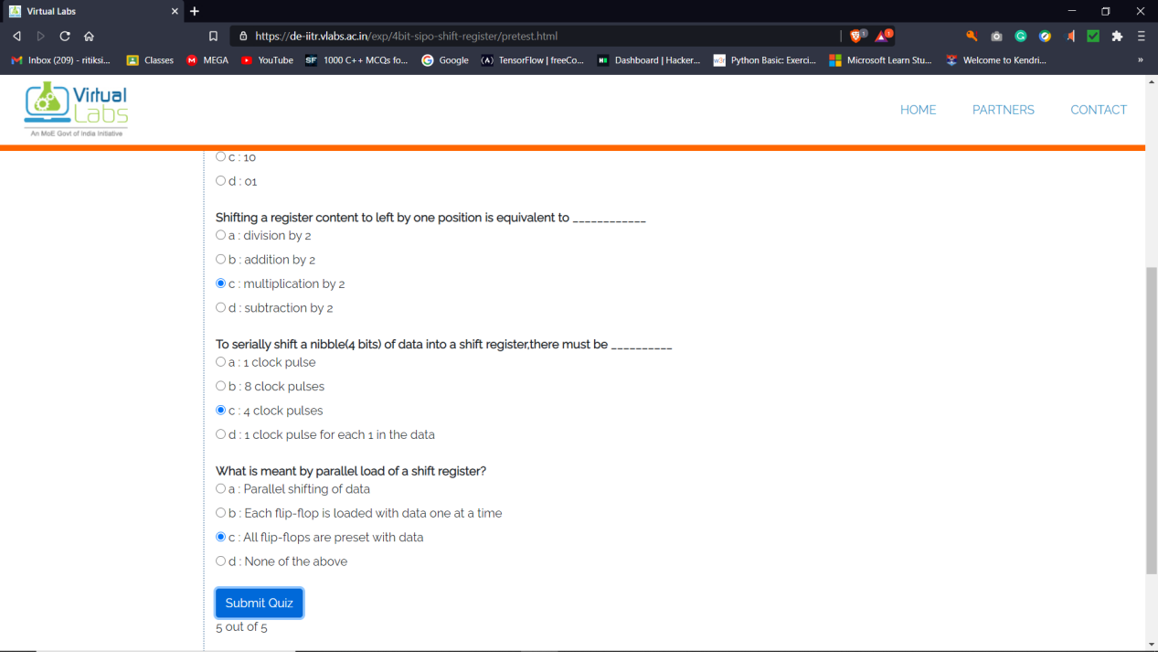

### POST TEST

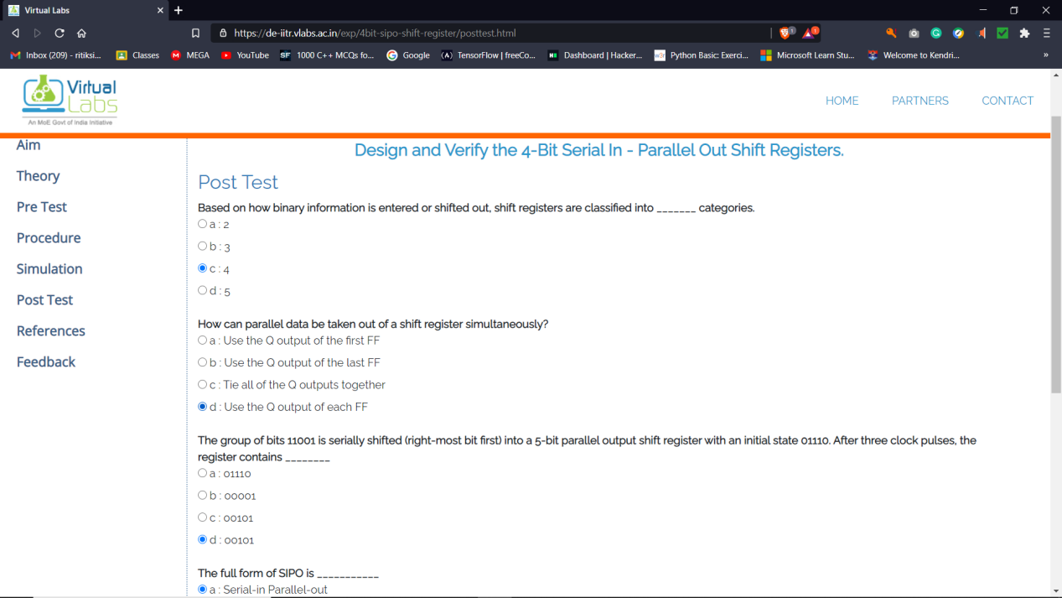

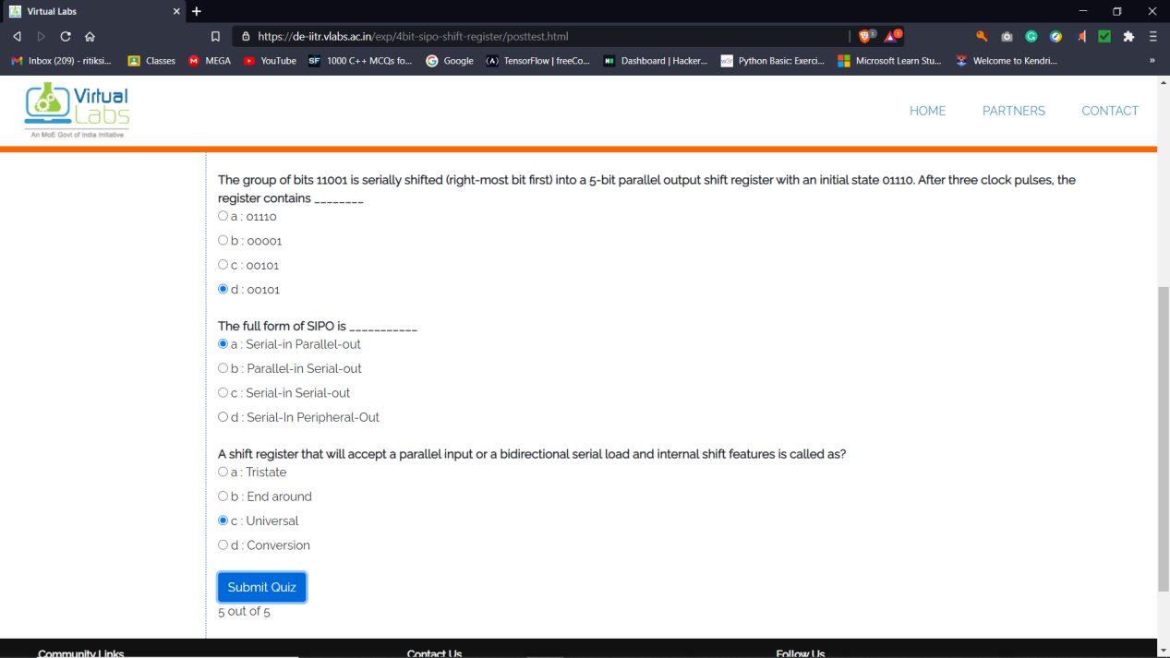

* **SIMULATION**

